Radiation Safety Considerations for the TPS Accelerators
R.J. Sheu, J. Liu, and J.P. Wang
National Synchrotron Radiation Research Center, 101 Hsin-Ann Road, Hsinchu Science Park, Hsinchu 30076, TAIWAN

Abstract

The Taiwan Photon Source (TPS) in National Synchrotron Radiation Research Center (NSRRC) will be a 3 GeV light source with a circumference of 518.4 m and operating fully at 400 mA in top-up mode, aiming to provide synchrotron light with extremely high brilliance and low emittance of less than 2 nm-rad [1]. It is now approaching its final design and will start civil construction by the end of this year. In addition to its main body of a 3 GeV electron storage ring, the accelerator complex includes a 150 MeV LINAC and a large 3 GeV concentric booster. Significant amount of radiation will be produced due to the loss of such high-energy electrons and result in radiation safety concerns. Fig.1 is a portion of the TPS layout showing the main accelerator components and its bulk shielding configuration. This study investigates the characteristics of prompt radiation field and some issues of induced activities due to the TPS operation. Starting from the assumed beam scenarios and using the FLUKA Monte Carlo simulations, energy spectra and dose distributions of the prompt radiation field for its shielding design were studied. Radiation environment around the personnel labyrinths and the underlying utility trenches for the TPS tunnel were also taken into account. Based on the FLUKA calculations, we can obtain the production rates of radionuclides in an irradiated material. Having the production rate and half-life of each isotope, we can predict the time behaviour of each isotope during beam irradiation and after shutdown. In addition, embedded with a comprehensive database for almost all the radionuclides, FLUKA can also generate and transport the secondary decay radiation and give a remnant dose distribution around an activated component. The residual activities around the accelerators and possible environmental impact have been evaluated and a final program managing the issues of residual activity in the TPS will be prepared accordingly. The paper summarizes the present status of the radiation safety evaluation for the TPS accelerators.

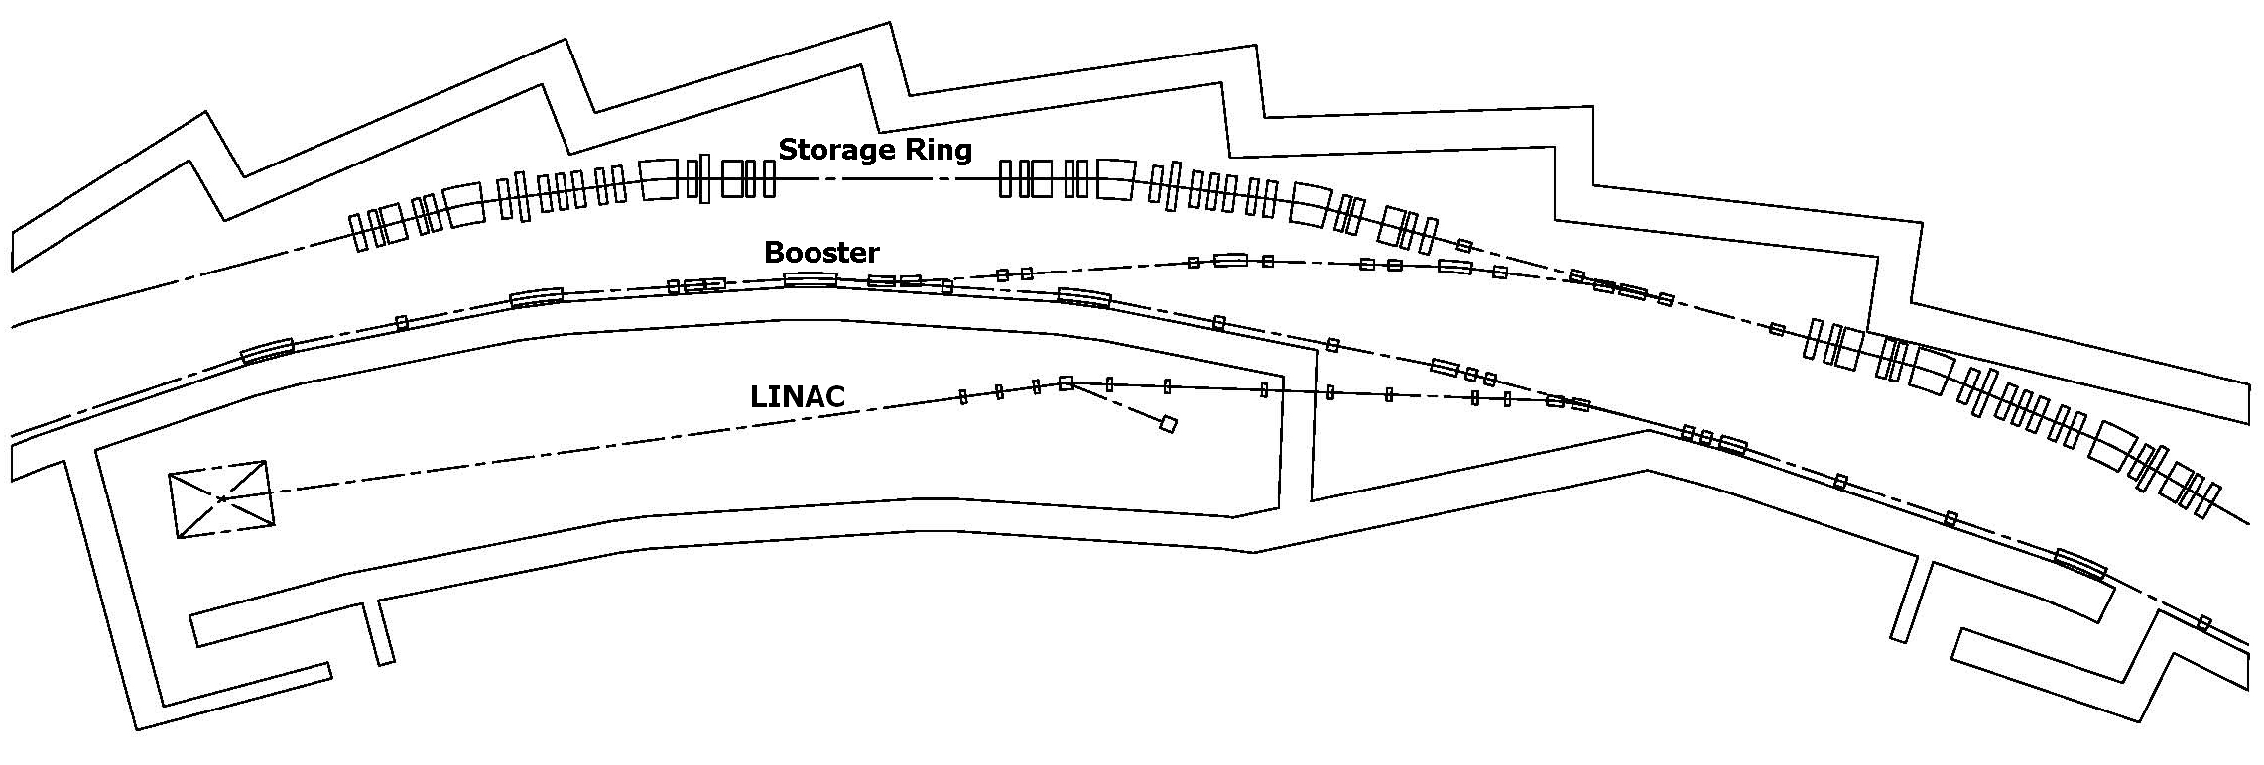
Fig.1 - A schematic layout of the main accelerator components and shielding design of the TPS.

References

[1] National Synchrotron Radiation Research Center, “Taiwan Photon Source (TPS) Design Handbook”, January 2009.

