Radiation Safety issues for the PF-AR in KEK
H. Nakamura, Y. Namito, K. Iijima and S. Ban
High Energy Accelerator Research Organization(KEK), 1-1 Oho, Tsukuba-shi Ibaraki-ken, 305-0801, Japan

Abstract

The Photon Factory Advanced Ring (PF-AR) is a synchrotron light source in High Energy Accelerator Research Organization (KEK). The following are main parameters of the PF-AR; the stored beam energy is 6.5 GeV, the injection energy is 3.0 GeV, the initial stored current is 60 mA, the beam lifetime at initial current is 20 hours, the number of beam bunch is one, the number of insertion devices is 6.
Figure 1 shows plan of the experimental halls of the PF-AR which are radiation control areas. The dose rates in the experimental halls should be less than 20 μSv/h and they are B.G. level usually.
However, when the beam lifetime decreased suddenly, the dose around the beam line hatch in the hall increased. These events related with the vacuum pressure of the ring and were observed when the gap of the insertion device was changed. This phenomenon is considered bremsstrahlung due to dust trapping.
For the the radiation safety, the radiation monitors were replaced near the beam line hatches and the interlock system which close the beam line when the event occurred was installed.
By improvement of the vacuum pressure, the sudden beam lifetime decrease has occured infrequently.

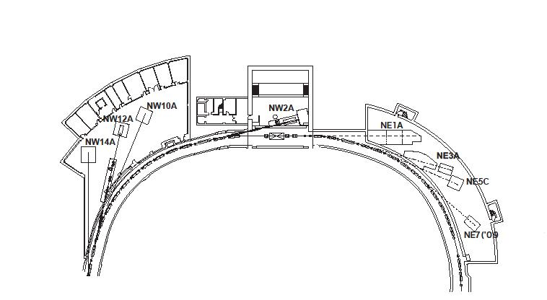
Fig.1 – Plan of the experimental hall of the PF-AR.

References

[1] Y. Kobayashi, “Present Status of PF-ring and PF-AR in KEK”, Proceedings of EPAC08, 2064-2066 (2008).
[2] H. Saeki, T. Momose, H. Ishimaru, “Observations of dust trapping phenomena in the TRISTAN accumulation ring and a study of dust removal in beam chamber”, Rev. Sci. Instrum., 62, 874-885 (1991).

