WAO Demographics 1996 through 2005
Peter Ingrassia , BNL, 16 November 2006

At the International Program Committee meeting in Trieste in September I offered to do some (simple) demographic analysis of the five previous workshops. What I present here holds few surprises. Copies of this summary and the spreadsheet containing the data are sent to the present International Program Committee members and the chairmen of the local program committees of the past workshops. I want to thank Ann-Marie Luhrs at BNL who typed in the attendance data for WAOs 1996 and 1998. I thank Tadahiko Katoh of KEK for sending me a spreadsheet with the attendance data for WAO 2003 so I did not have to input that data. I thank Roger Bailey, CERN, and Bob Mau, FNAL, for making my life easier by putting the WAO 2001 and WAO 2005 attendance data on the web. Finally I thank Ron Lauze of TJNAF who was kind enough to fax me a copy of the 1996 WAO attendance list rather than reminding me of how forgetful I am, and for not telling me to look up for myself the attendance list in the WAO 1996 proceedings.

Results of the data mining:
Figures one through five are self-explanatory. Each of the five pie charts shows the fraction of attendance at each workshop by continent – we have had no participants from Australia or Antarctica. The charts show what we already know – that if we hold a workshop in Asia, then the majority of participants will come from Asia. If we hold a workshop in Europe, then the majority of participants will come from Europe. It is interesting to note that if we ignore the three workshops held in North America, we find that participation from North America institutions is larger at Europe and Asia workshops than comparable participation at North America workshops by Europe and Asia institutions. I can only conclude that participants from North America like to travel.

Figure six shows the number of participants that registered and the number of different institutions that were represented at each workshop. We can see that the CERN and FNAL workshops drew approximately the same number of participants and institutions. The TRIUMP workshop drew the largest number of participants and institutions while the TJANF workshop, the first one, drew the smallest number.

Figure seven shows the breakdown of the 105 institutions that supported the five workshops by sending participants. The largest fraction is represented by “Research Laboratories”. Examples of research laboratories include CERN, KEK, ESRF, and MAX-LAB. The second largest fraction was the University Laboratory category which includes laboratories at universities like CESR at Cornell (US), or Michigan State (US) and students from universities like Osaka, or the University of Minnesota. The third largest sector represented was the commercial sector which includes companies like Theragenics or Northrop-Grumman. The fourth largest sector represented was that of government agencies like the US Department of Energy or the Canadian Nuclear Safety Commission. The smallest institutional component was that of Medical or Hospital facilities like Massachusetts General Hospital or the King Faisal Specialist Hospital.

Finally figure eight shows how often individuals returned to the workshops. Eight individuals attended all five workshops. Five individuals attended four workshops. Fifteen people attended three workshops. Fifty people attended two workshops. Three hundred and forty three people attended only one workshop. Out of 421 individuals who attended, only 18.5% attended more than one workshop. I find this statistic troubling. I have to assume that the small fraction of people who return is due to the fact that most of the institutions that send participants, like research laboratories, or universities, are small or have small travel budgets for the purpose of sending accelerator operators to a gathering other than a “school”.

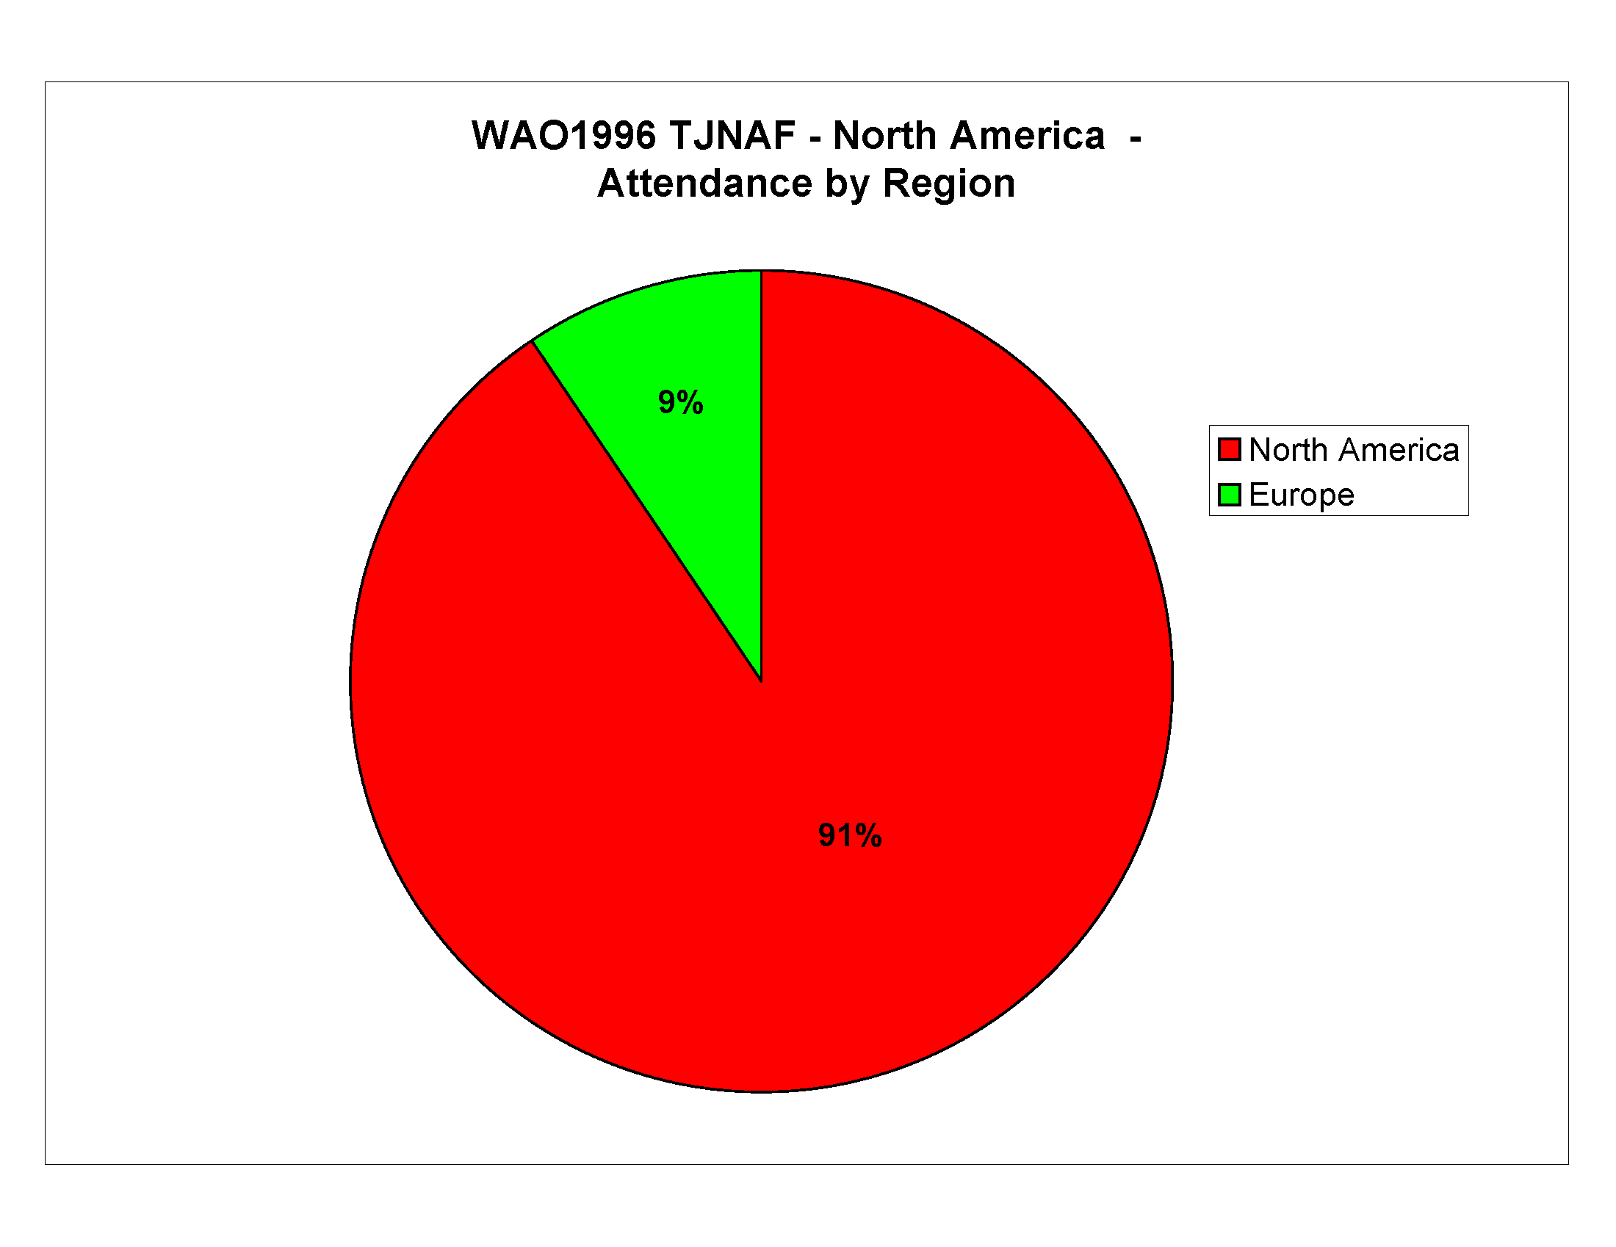
Figure 1. Attendance at WAO 1996 – by Region (Continent)
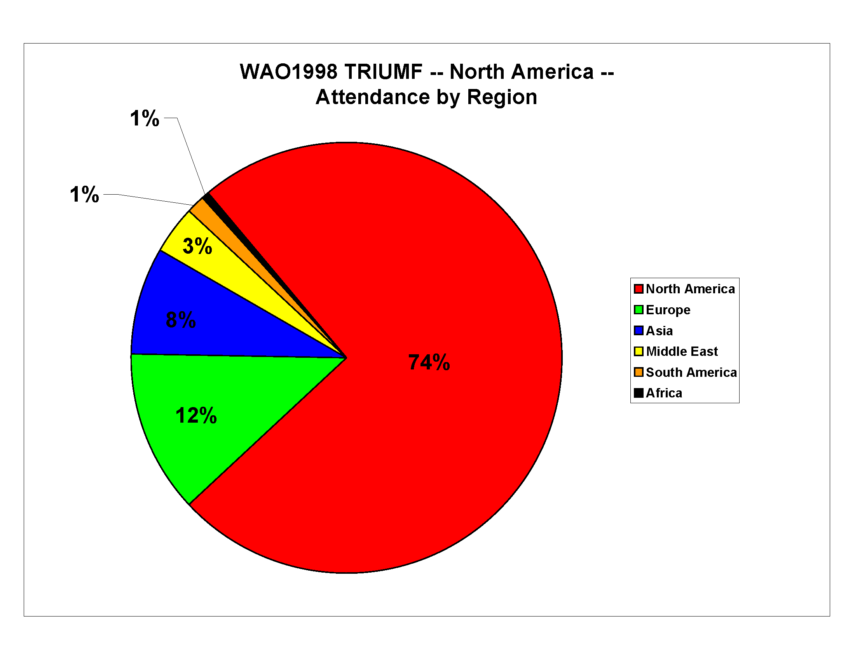Figure 2. Attendance at WAO 1998 – by Region (Continent)
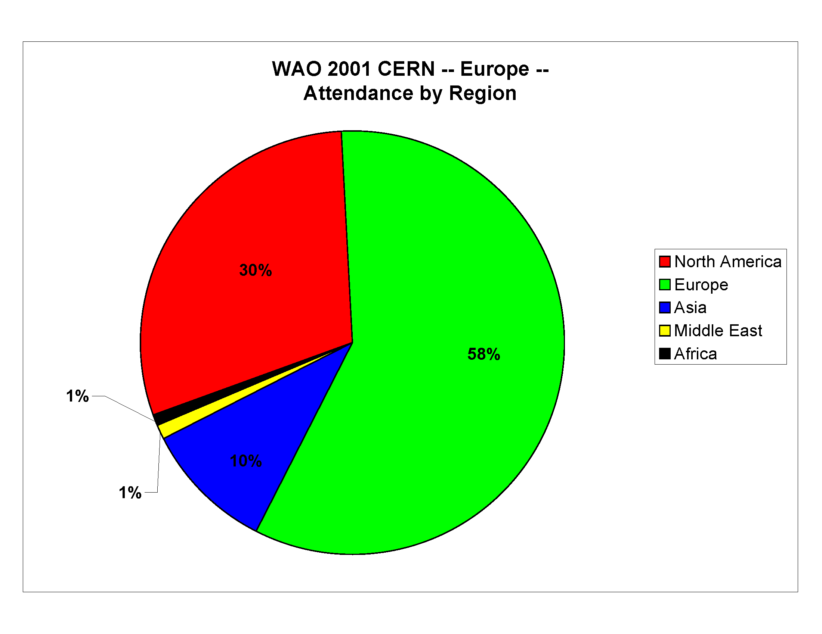
Figure 3. Attendance at WAO 2001 – by Region (Continent)
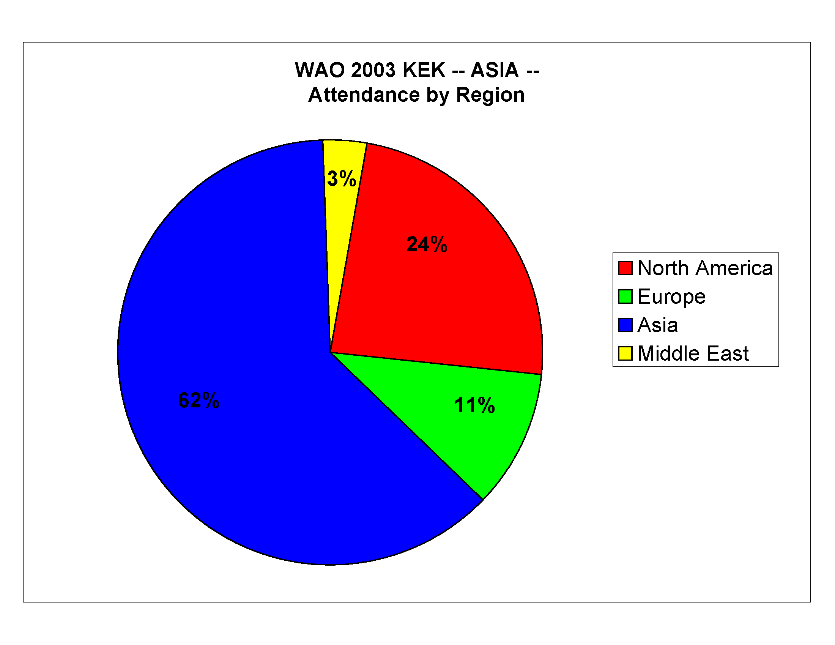
Figure 4. Attendance at WAO 2003 – by Region (Continent)
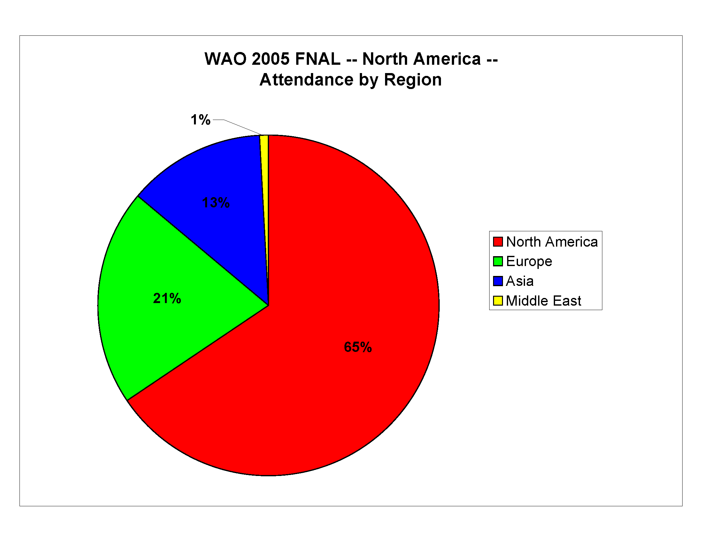

Figure 5. Attendance at WAO 2005 – by Region (Continent)
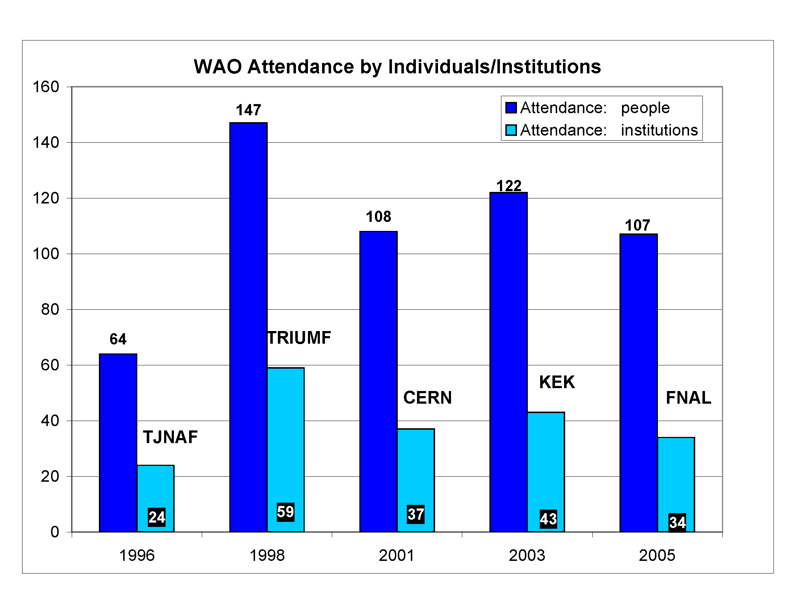
Figure 6. WAO attendance by individuals and institutions
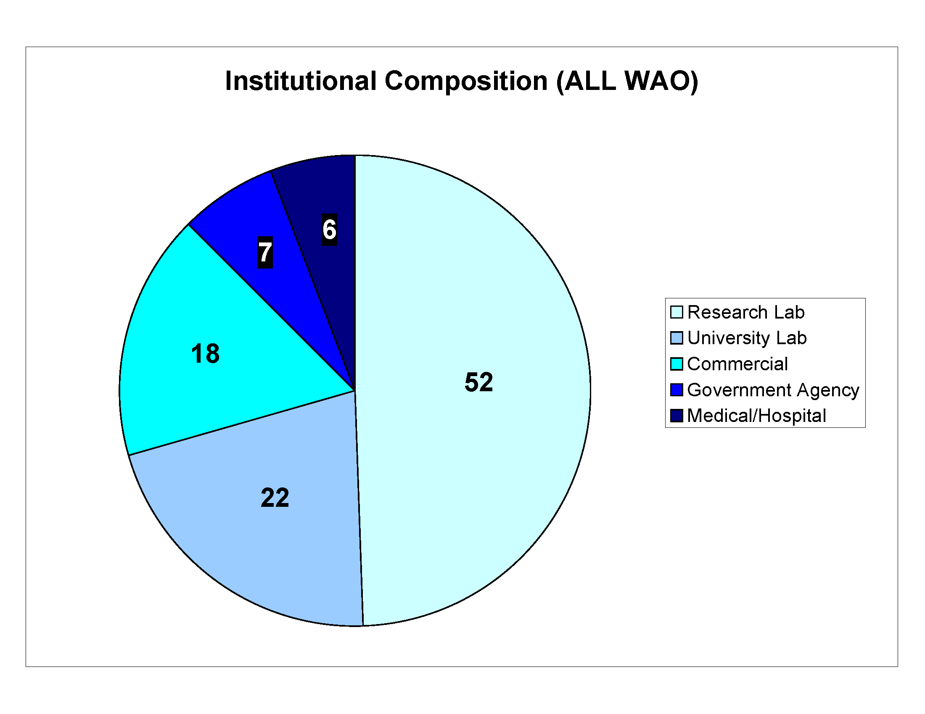
Figure 7. Institutional involvement at WAO
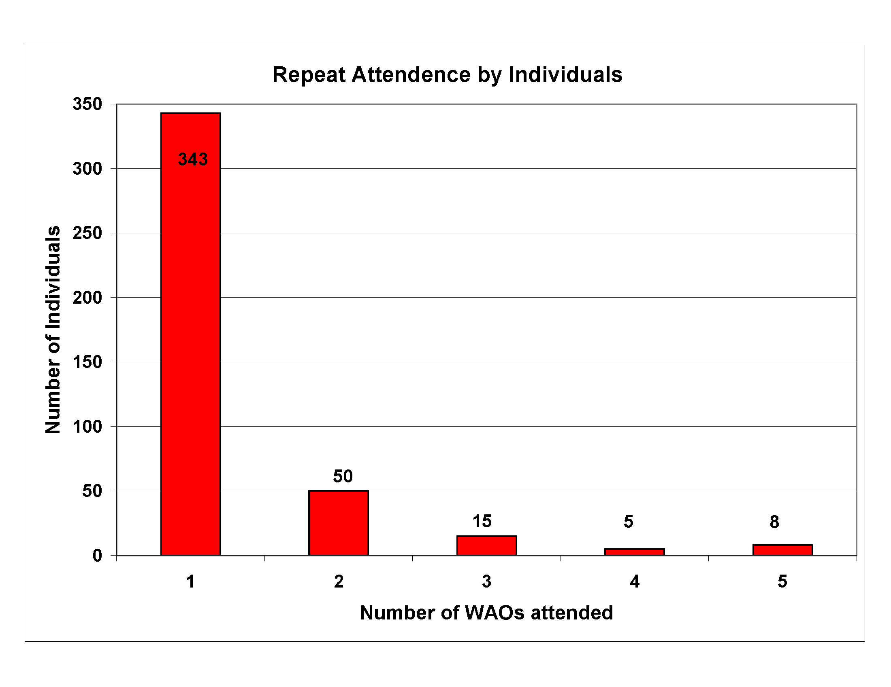
Figure 8. Frequency of attendance by individuals

