Challenges and opportunities for pump-probe spectroscopy
at synchrotron radiation sources

Fausto Sirotti

Lab. Physique de la Matière Condensée, CNRS and Ecole Polytechnique, 91128 Palaiseau, France
SOLEIL Synchrotron, l’Orme des Merisiers, 91192 Gif sur Yvette, France

Email: fausto.sirotti@polytechnique.edu

Synchrotron radiation sources are the most effective tool to perform spectroscopic studies: high repetition rate, good energy resolution and easily tunable energy and polarization were developed over the last 30 years. Coupling fs laser excitations to synchrotron radiation spectroscopy experiment can allow us to take advantage of all these developments on insertion devices, beamlines and experimental station. When surface science techniques are used, the possibility to perform a complete characterization of the analyzed samples by coupling several techniques is also important for obtaining reliable results. I will present examples of pump/ probe electron spectroscopy studies performed on different synchrotron radiation sources operated in normal [1,2] and in low alpha [3] operation. I will discuss the constraints introduced by the laser excited experiments in the synchrotron beamline operation as well as the complementary experiments indispensable for the development of a successful scientific program.

1]
2]
3]
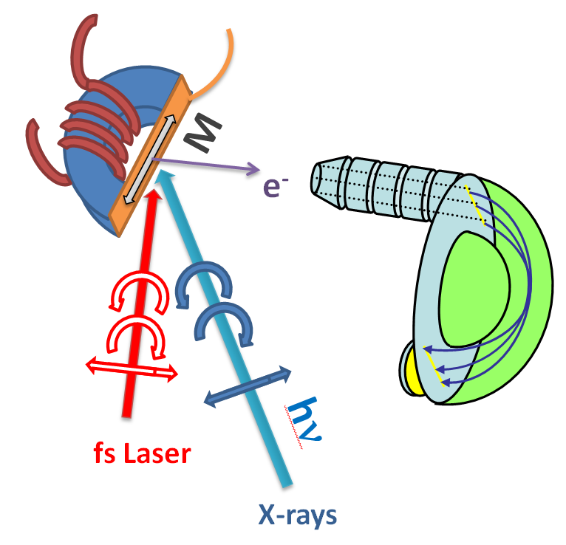
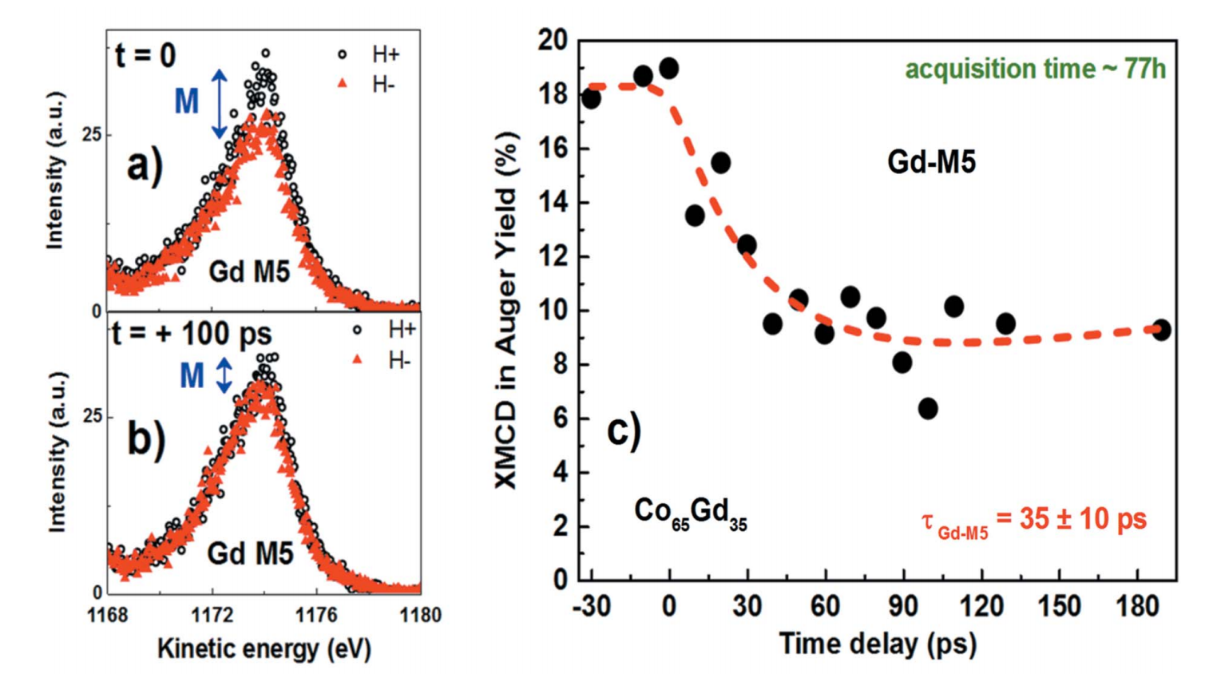
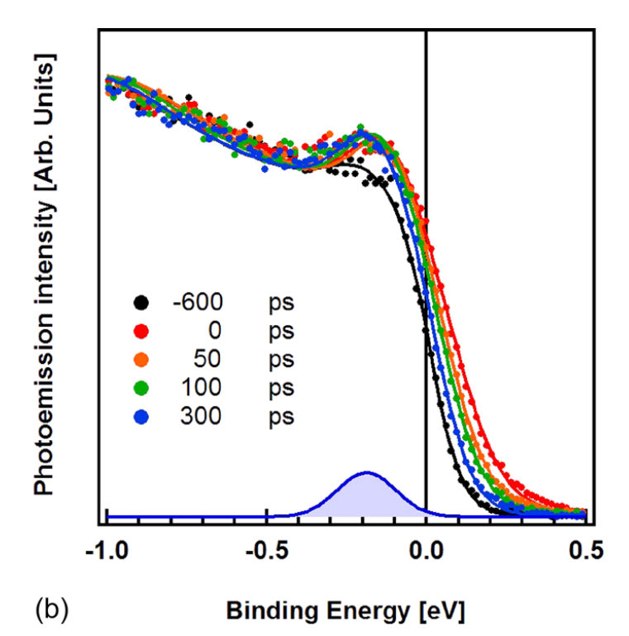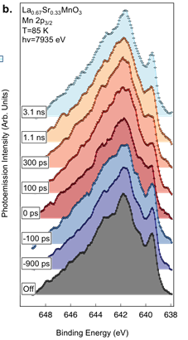

Figure. Examples of pump probe photoelectron spectroscopy experiments of performed at SOLEIL [1,3] and SPRING 8[2] using fs laser pulses.

References
[1] F. Pressacco et al. Structural Dynamics 5, 034501 (2018)
[2] T. Pincelli et al. submitted
[3] M.G. Silly et al. J. Synchrotron Rad. 24, 886–897 (2017)

