Structure, electronic structure, dielectric and ferroelectric properties of lead free perovskite Ba_{1-x}Ca_{x}Ti_{0.9}Zr_{0.1}O₃

G. Herrera-Pérez¹, J. Canche-Tello², M. E. Montero-Cabrera², J. R. Plaisier³, D. Eichert³, A. Reyes-Rojas², L. E. Fuentes-Cobas²,
¹Catedrático CONACyT assigned to Centro de Investigación en Materiales Avanzados (CIMAV) S. C., Miguel de Cervantes 120, Chihuahua, Chih. 31136, Mexico
²Centro de Investigación en Materiales Avanzados (CIMAV) S. C., Miguel de Cervantes 120, Chihuahua, Chih. 31136, Mexico
³Elettra-Sincotrone Trieste S. C.p.A, Strada Statale 14, Km 163.5, Bassovizza, Trieste 34149, Italy

Email: guillermo.herrera@cimav.edu.mx

The electro-ceramic industry has focused their attention on replacing lead-based materials due to their toxic effects and unfavorable environment impact [1]. Barium titanate doped with calcium and zirconium is a well-known perovskite-type solid solution is a potential candidate that will cover this task in particular in the aeronautic industry [2]. Ba_{1-x}Ca_{x}Ti_{0.9}Zr_{0.1}O₃ (where x = 0, 0.1 and 0.15) compositions are located near the called morphotropic phase boundary (MPB) that shows a coexistence of ferroelectric phases [1]. This work shows the relationship between the crystal and electronic structure with the dielectric and piezo-ferroelectric properties for these compositions prepared by the modified Pechini method [3]. The refinement (using the Rietveld method) of high-resolution X-ray diffraction (HR-XRD) patterns collected at the beamline 7.1 MCX (Elettra Sincrotrone) suggest the presence of single tetragonal phase over the obtained compositions. Figure 1a shows a two-dimensional grazing incidence X-ray diffraction pattern 2D-XRD collected for a Ba_{0.80}Ca_{0.20}Ti_{0.9}Zr_{0.1}O₃ compound. The dielectric analysis indicates a relaxor behavior with a Curie temperature in a range of 100-120 ºC. The ferroelectric evaluation complements the electrical characterization for these compositions [4]. Micro–X-ray absorption near edge spectroscopy (µ-XANES) was performed at the beamline 10.1L X-ray fluorescence (Elettra Sincrotrone) with the purpose to monitor possible changes of electronic structure profile at the Ti K-edge, due to the local distortions as Ca²⁺ increases (Figure 1b).

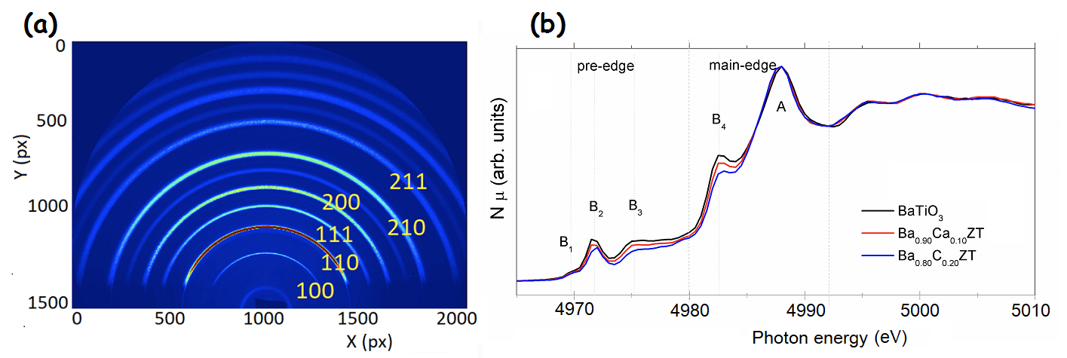
Figure 1. (a) 2D-GIXRD pattern collected at the 7.1 MCX beamline. (b) Normalized Ti K-edge spectra for the reference compound (BaTiO₃) and other two representative compositions in order to monitor µ-XANES changes in the B₁, B₂, B₃ and B₄ features as the Ca concentration increases.

References
[1] Reyes-Montero A, Rubio-Marcos F, Pardo L, et al 2018 J. Mater. Chem. A 6 5419
[2] Jiménez K, Herrera-Pérez G, 2018 J. Mater. Sci. Engin. A 8 32-42
[3] Herrera-Pérez G, Morales D, Paraguay-Delgado F, et al 2016 J. Appl. Phys. 120 094303
[4] Herrera-Pérez G, Castillo-Sandoval I, Solís-Canto O, et al 2018 Mater. Research 21(2) e20170605

