Overview on Time-Resolved Schemes for Synchrotrons
S. Di Mitri¹
¹Elettra – Sincrotrone Trieste S.C.p.A., 34149, Basovizza, Trieste, Italy

Email: simone.dimitri@elettra.eu

The last decade has seen a renaissance of machine physics studies and technological advancements that aim to upgrade at least 15 synchrotron light sources worldwide to diffraction-limited storage rings [1]. This is expected to improve the average spectral brightness and transversally coherent fraction of photons by several orders of magnitude in the soft and hard x-ray wavelength range, at the expense of pulse durations longer than ∼40 ps rms. This work discusses the compatibility of schemes for the generation of picosecond and sub-picosecond photon pulse durations in synchrotron light sources with standard multi-bunch user operation and, in particular, diffraction-limited electron optics design [2]. The question of this compatibility is answered taking into consideration the storage ring beam energy and the constraint of existing synchrotrons’ infrastructure.

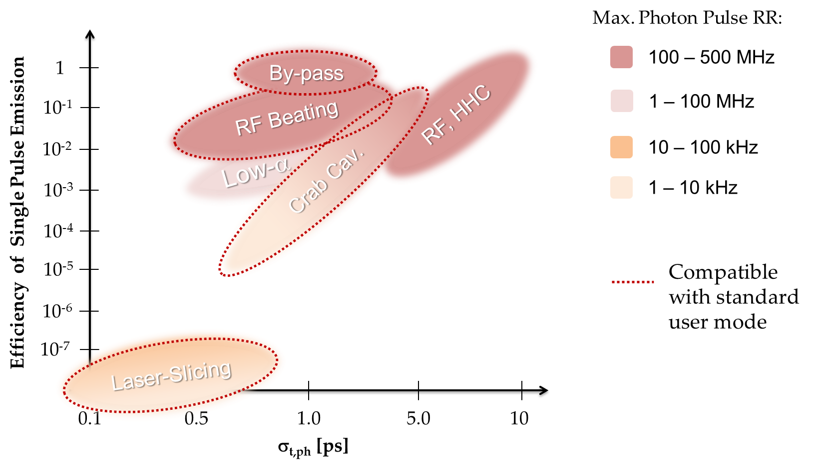
Figure. Schematic representation of schemes for the generation of short photon pulses at synchrotron light sources.

References
[1] Ultra-low emittance light sources, Synch. Rad. News 27, 6, Taylor & Francis, ed. R. Frahm, M. C. Martin and M. Suzuki, ISSN 0894-0886, Philadelphia, PA 19106 USA (2014).
[2] S. Di Mitri, One way only to synchrotron light sources upgrade?, J. Synchrotron Rad. 25 (2018).

