Large Polaron evidence in the Ultrafast THz response of Lead-Halide Perovskites

Eugenio Cinquanta^{1,2}, Daniele Meggiolaro^{3,4}, Silvia G. Motti⁵, Marina Gandini⁵, Marcelo J. P. Alcocer^{1, 6}, Quinten Adriaan Akkerman^{7, 8}, Caterina Vozzi², Liberato Manna⁷, Filippo De Angelis ^{3,4}, Annamaria Petrozza^{5*} and Salvatore Stagira^{1,2}
¹ Dipartimento di Fisica, Politecnico di Milano, Milano, Italy
² Istituto di Fotonica e Nanotecnologie, Consiglio Nazionale delle Ricerche, Milano, Italy
³ Computational Laboratory for Hybrid/Organic Photovoltaics, CNR-IMS, Perugia, Italy
⁴ D3-CompuNet, Istituto Italiano di Tecnologia, Genova, Italy
⁵ Center for Nano Science and Technology, Istituto Italiano di Tecnologia, Milano, Italy;
⁶ Solid State Physics and NanoLund, Lund University, P.O. Box 118, SE-221 00 Lund, Sweden
⁷ Department of Nanochemistry, Istituto Italiano di Tecnologia, Via Morego 30, 16163 Genova, Italy
⁸ Dipartimento di Chimica e Chimica Industriale, Università degli Studi di Genova, Via Dodecaneso, 31, 16146, Genova, Italy

Email: eugenioluigi.cinquanta@polimi.it

Hybrid Organic-Inorganic Perovskites (HOIPs) represent a promising platform for emerging optoelectronics devices due to their exceptional physical properties. Unexpectedly, HOIPs show only a moderate carrier mobility that looks conflicting with their carrier effective mass and lifetimes. The presence of large polarons has been proposed as a possible explanation for the limited carrier mobility in this class of materials.
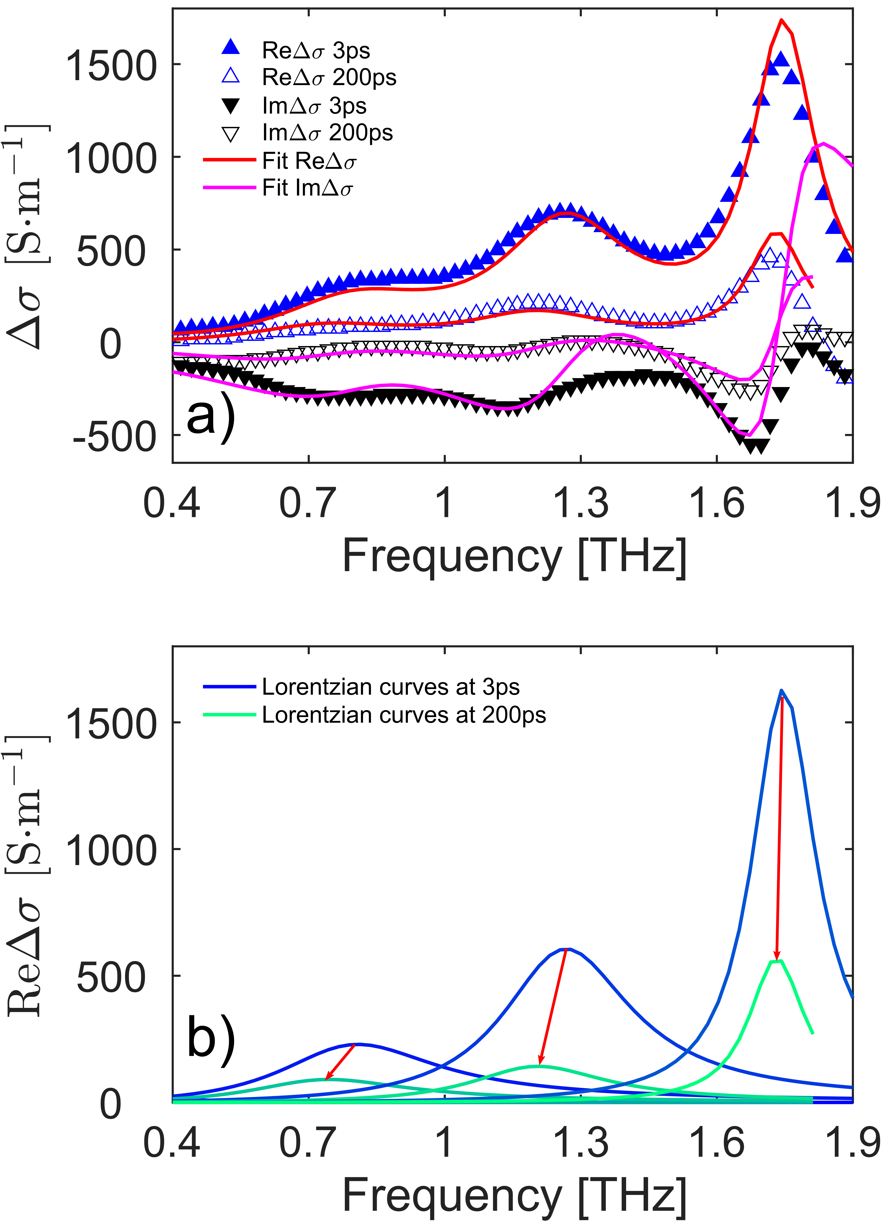
Figure 1 Transient optical conductivity at 3 and at 200 together with the Drude-Lorentz fit; b) real part of the Lorentzian curves at 3 and 200 ps. Red arrows indicate the redshift of each component.
By combining Ultrafast THz spectroscopy with DFT calculations, we demonstrate the presence of large polarons in the dielectric response of thin films of CsPbBr₃. Figure 1a) shows the pump induced optical conductivity at 3 and 200 ps after the photoexcitation. At 3 ps, three main peaks emerge in the 0.4-1.9 THz region that bare almost the whole intensity. Theory predicts that the formation of a large polaron is expected after the carrier’s photo-injection due to the coupling with lattice IR modes. The largest intensity is predicted for four Pb-Br-Pb bending modes at 0.75, 0.84, 1.35 and 1.88 THz that matches the experimental features (0.81, 1.26 and 1.74 THz). Figure 1b) shows the real part of the Lorentzian fitting curves. A redshift affects the curves at 200 ps that can be explained in terms of photo induced lattice deformation. Once the photoexcitation creates a hole in the top of the valence band, the Pb-Br bonds shorten, and the lattice shrinks with the resulting phonons blueshift; as the injected charge starts to relax, the lattice can relax with the consequent phonons softening. We hence observe a distinctive coupling between the photo-generated charges and bending modes of the lattice. The deviation from a free-carriers dispersion and the influence of the photoinjected charge on the lattice modes relaxation reveal the polaronic nature of the carriers.

